OPPORTUNITY LEVEL |  | SPONSORSHIP |  |  |  |  | ADVERTISING
 |  | DIAMOND | GOLD | SILVER | BRONZE
 |  | 1 | 2 | 3 | 4 |  | 5 | 6 | 7 | 8
Title and media sponsor for all individual events
Corporate logo on large banner
Corporate logo on our website
Corporate logo on shared sponsorship banner
Link to company website from our website
Social Media sponsorship acknowledgement
Acknowledgement for the entire year
Program/Patron Book Advertisement |  | FULL PAGE | FULL PAGE | 1/2 PAGE | 1/4 PAGE |  | FULL PAGE | 1/2 PAGE | 1/4 PAGE | B. CARD
TOTAL INVESTMENT |  | $2500 | $2000 | $1500 | $1,000 |  | $600 | $300 | $150 | $100

I would like to purchase the following opportunity level (1-8): |  |  |  |  |  |  |  | Total $:
Name:
Contact Person: |  |  |  |  |  | Telephone:
Address: |  |  |  |  |  | Email:
Committee Member Name:
Please make cheques payable to: Comunita Racalmutese Maria S.S. Del Monte
Mail cheque along with a copy of the form to:
Hamilton Festival Racalmutese Maria Del Monte
72 Murray St. West
Hamilton, ON L8L 1B3

Please review next page for advertising sizes
Provide ads as Full Colour PDF files.

Please forward your program ad or artwork by May 5th to Gasper Lipari at gasper@capitalpress.ca or contact Gasper directly at 905-393-7575, to discuss any technical questions you may have.

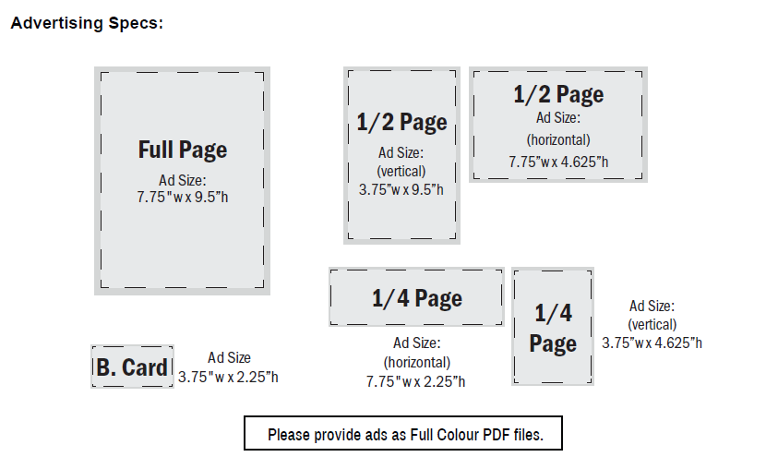

Please make cheques payable to: Comunita Racalmutese Maria S.S. Del Monte
Mail cheque along with a copy of the form to:
Hamilton Festival Racalmutese Maria Del Monte
72 Murray St. West
Hamilton, ON L8L 1B3

Please forward your program ad or artwork by May 5th to Gasper Lipari at gasper@capitalpress.ca or contact Gasper directly at 905-393-7575, to discuss any technical questions you may have.

